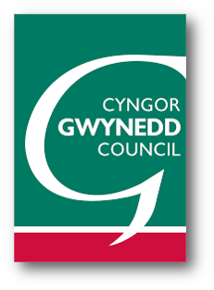
Your Details:

Date:

Name:

E-mail Address:

I’m responding as: (Please tick the relevant response)
Parent
Staff
Governor
Pupil

Other (please specify)

If you wish to be notified when the consultation report is published, please tick the appropriate box
Yes, I wish to be notified

No, I do not wish to be notified
In accordance with data protection legislation requirements, we are required to inform you of the following:
Gwynedd Council is seeking your views on this proposal as part of a statutory consultation process. The details you provide will be used for this purpose only. The information may be shared with agencies involved in the consultation (e.g. the Welsh Government) solely in order to respond to specific matters that you may have raised. We will continue to consider your comments, whichever option is chosen. Your personal details will be kept for 7 years.
With your permission, we may reproduce responses, in full or having taken out personal details such as names and addresses, in a report to the Cabinet on the statutory consultation.
If you do not wish the Council to publish your response, please state below by pacing a ✓ in the relevant box, please:
* Choose one of the following answers
I agree that the Council can publish my response in full including my personal information.

I agree that the Council can publish my response, after removing my personal information.

No, the Council should not publish my response.
For further information about your rights and the Council’s Data Protection Officer visit the Privacy section on the Council website.
Please note that these responses are comments and not objections to the proposal.
There will be an opportunity to object to the proposal should a statutory notice be published.
Please return your response to:
Modernising Education Office,
Education Department, Gwynedd Council,
Caernarfon
LL55 1SH
or ModernisingEducation@gwynedd.llyw.cymru

Closing Date: 13:00 on Tuesday, 23 February 2021

Comments:

